Cognizant Digital Nurture 4.0 – DotNet FSE Deep Skilling

# Week 1 Exercises Report – Roll No: 22052918

## Exercise 2: E-commerce Platform Search Function

This C# program simulates a product search feature for an e-commerce platform. It allows searching products by keyword and lists the results sorted by price.

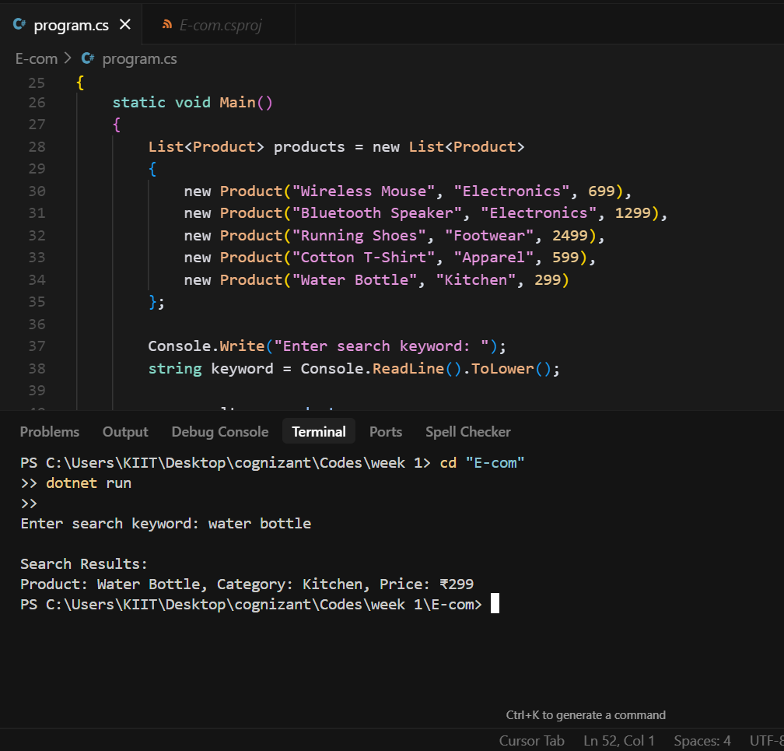

## Exercise 7: Financial Forecasting

This program demonstrates simple financial forecasting using a 3-month moving average on historical revenue data.

